MONITORING AND RECOMMENDATION REPORT

1. Objective
The objective of this report is to explain how scheduled reports, report distribution and KPI alerts can help Global Superstore management monitor business performance.

2. Dashboard Overview
The Power BI Executive Dashboard was reviewed using the overall dataset without a region or category filter. It displays total sales of approximately 12.64 million, total profit of 1.47 million, around 26 thousand orders and a profit margin of 0.12. It also shows sales by region, sales by category, monthly sales trend, profit by segment and top customers.
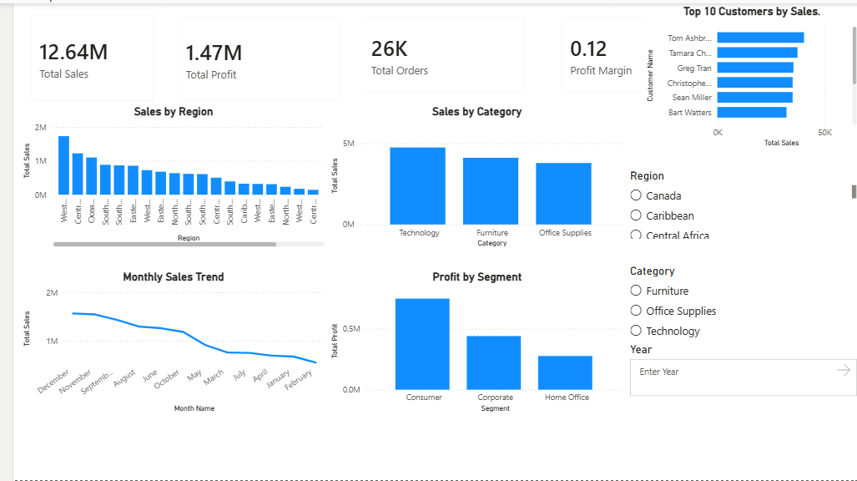
Figure 1: Executive Dashboard showing overall business performance.

3. Monitoring Scenario
A regional branch is experiencing a decline in profitability. The monitoring plan identifies the problem when profit margin falls below 10%. A second warning is planned when regional sales decline by 15%.

4. Alert Recipients and Actions
Alert | Recipient | Action
Profit margin below 10% | Regional Manager and Finance Manager | Review expenses and profit performance
Regional sales decline by 15% | Regional Manager | Check sales trends and customer demand
Returns increase by 20% | Operations Manager | Identify reasons for product returns

5. Recommendations
- Review regional expenses and reduce avoidable costs.
- Identify low-performing products and categories.
- Study customer demand and improve sales strategies.
- Monitor returns to identify product or delivery issues.
- Review KPI reports regularly and share them with responsible managers.

6. Conclusion
The reporting plan, distribution matrix and KPI alert conditions provide a simple approach for monitoring business performance. Regular review can help managers identify problems early and take corrective action. The schedules and alert thresholds in this practical are proposed designs; live email subscriptions and alerts require configuration in Power BI Service.

